**Metroidvania Map Kit Getting Started Guide**

**Introduction**

This guide will describe the complete process of configuring the Metroidvania map.You can build your own map function accoding to this guide.

**Preparation**

Before starting,prepare the following components:

1. Unity Input System
2. Existed scene,just like:

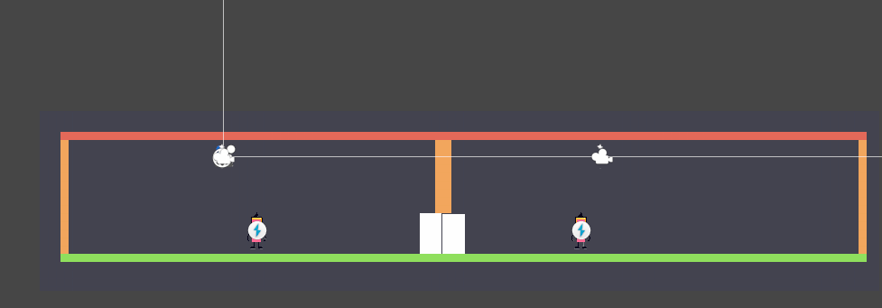

**Add Layer**

Add a Layer which name is “map” for map elements.

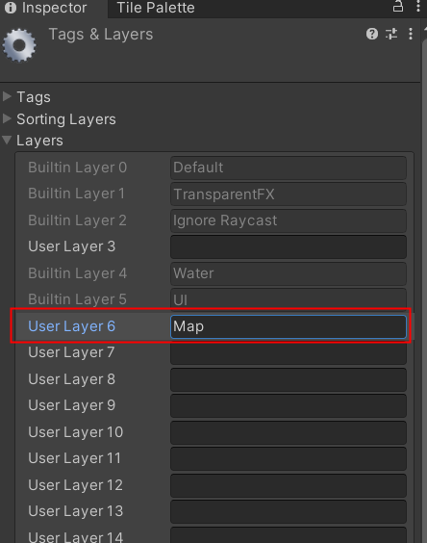

**Add Cameras for Map**

Add “0.Map Camera” in prefabs to MainCamera, and set the “Culling Mask” to “Map”

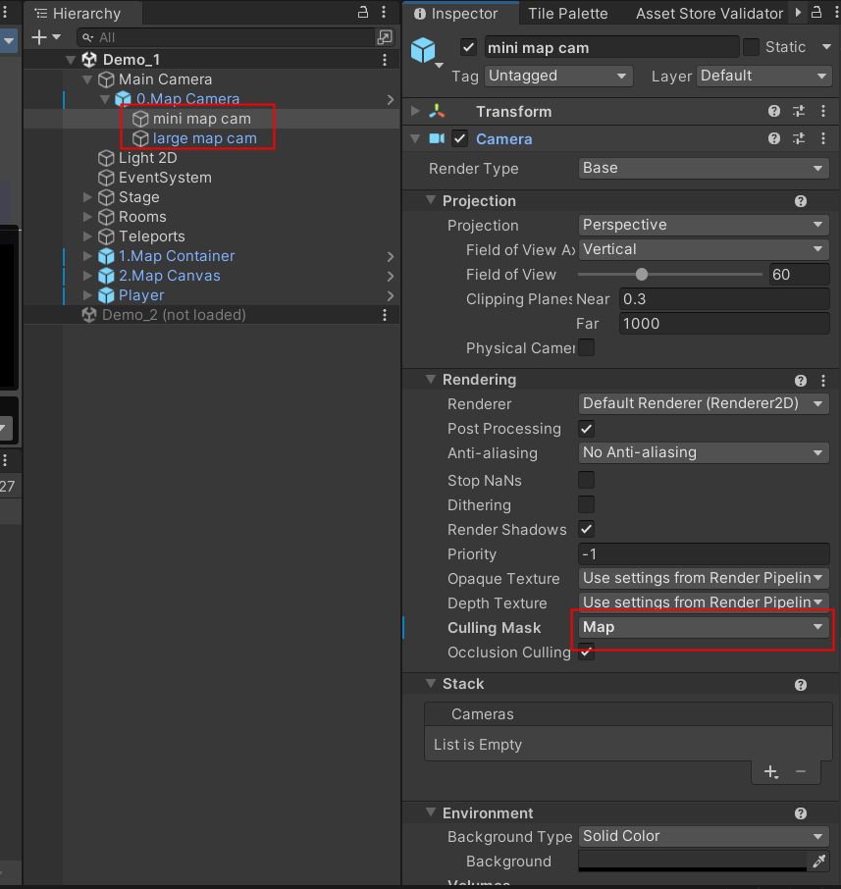

**Add Map In Scene**

Add “1.Map Container” in Prefabs to Scene,set “Layer” to “Map”,

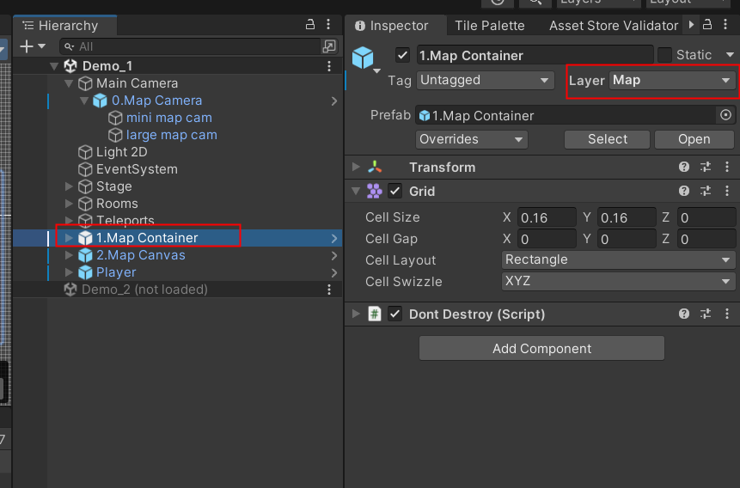

And set “Revealer Object” in “Fog” to our player object or set “Revealer Tag” to our player Tag.

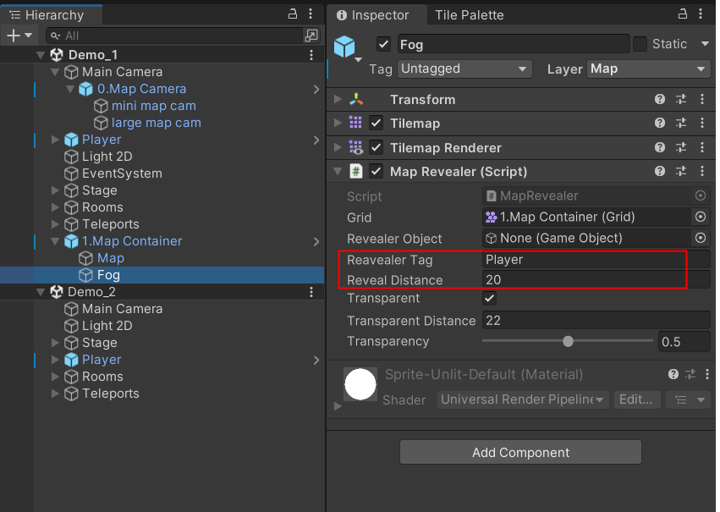

**Draw the Map**

Open the TilePalette,draw the Map

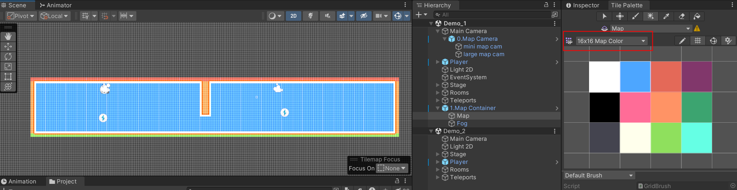

And draw the fog

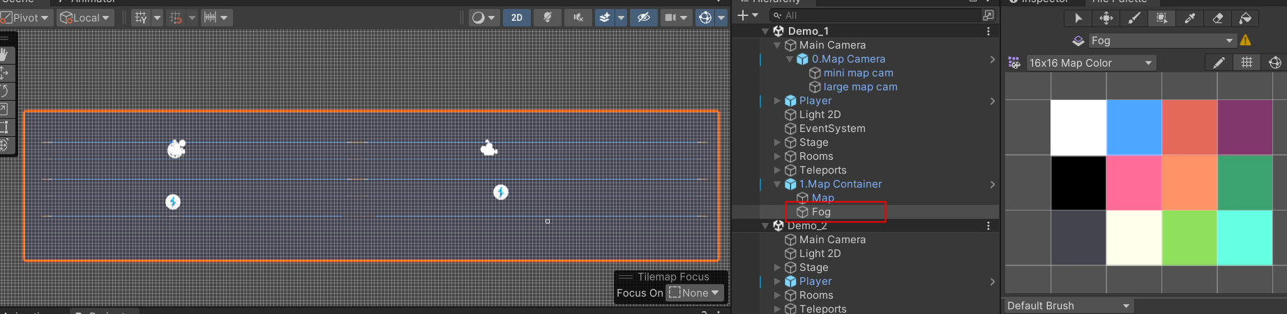

**Add InputAction for controlling the large map**

Add a few button actions

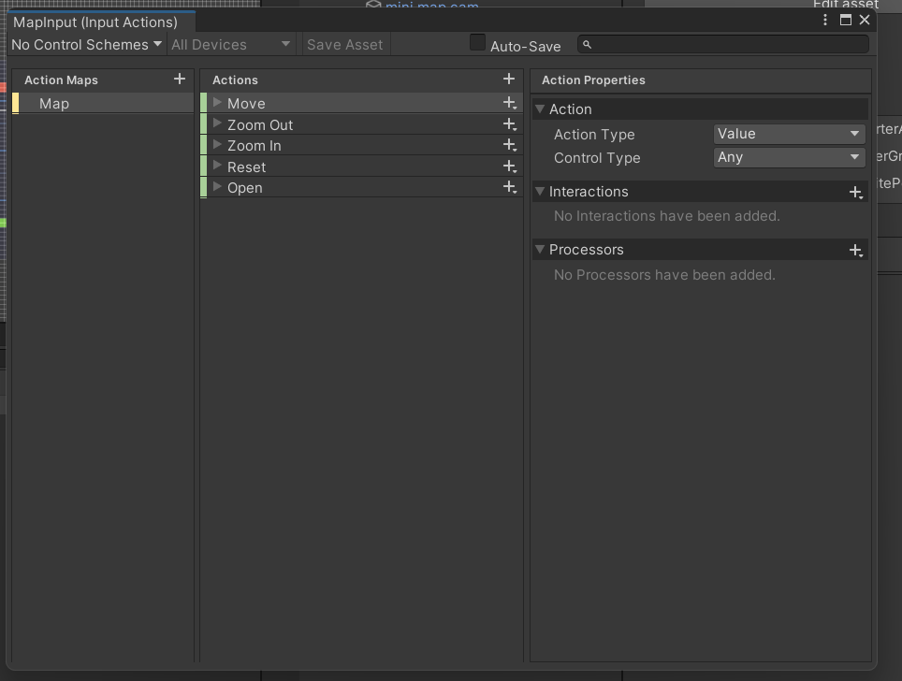

**Add Map Canvas In Scene**

Add “2.Map Canvas” in prefabs to scene.

Set the InputAction which added in the previous step to the actions of Map Canvas,and set Events-Map-Open to MapSwitcher.InputSwitchMap

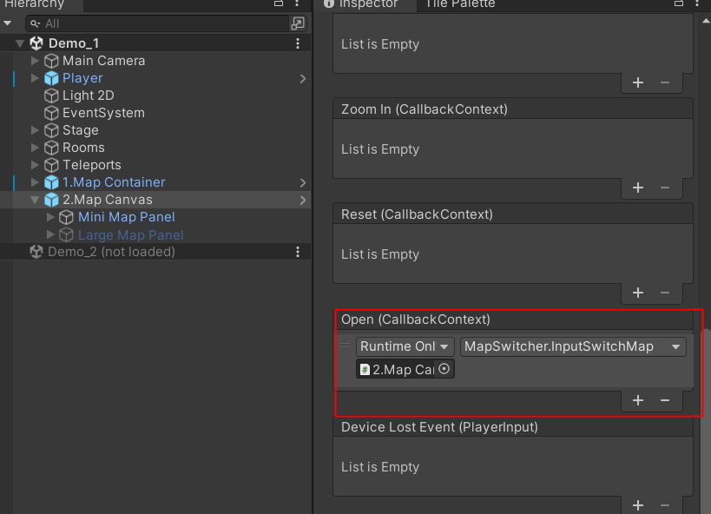

Set the InputAction to the actions of “Large Map”,and set the actions in the Events-Map for controlling the large map

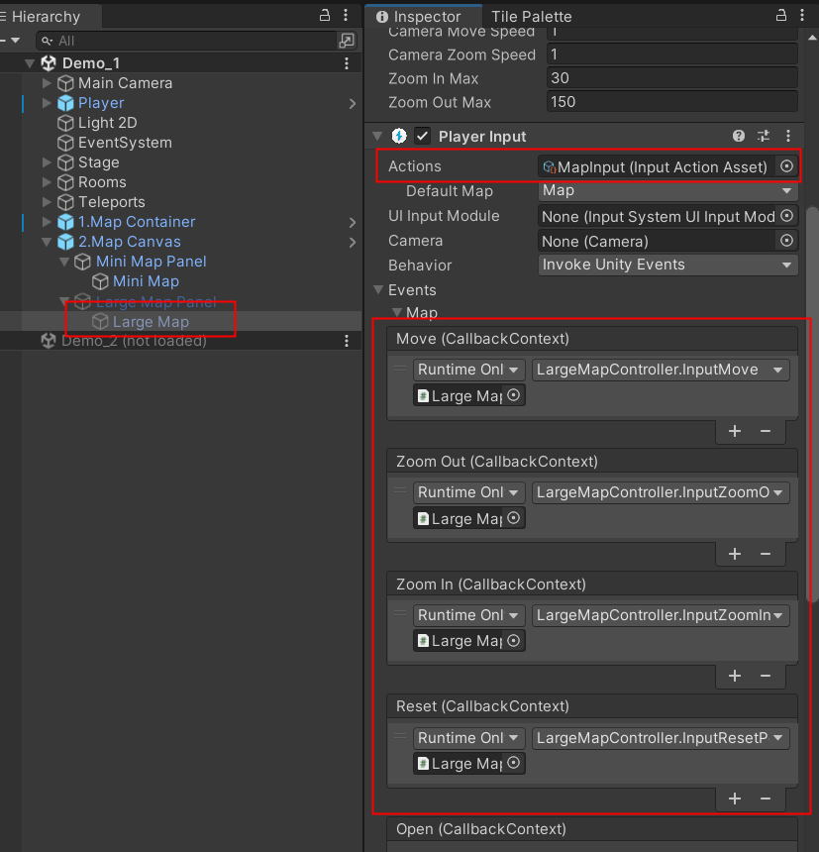

Set the player object to “Player” or Set the tag of player to “Player Tag” in “Large Map Controller” in “Large Map”,and set “large map camera” which added in previous step to “Camera”

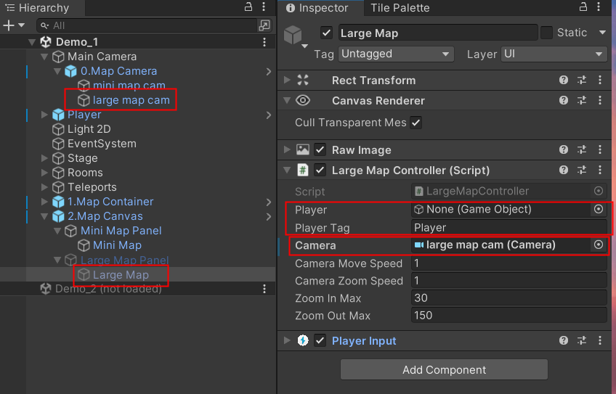

**Add Icon in Player**

Now,we can watch the map in game.

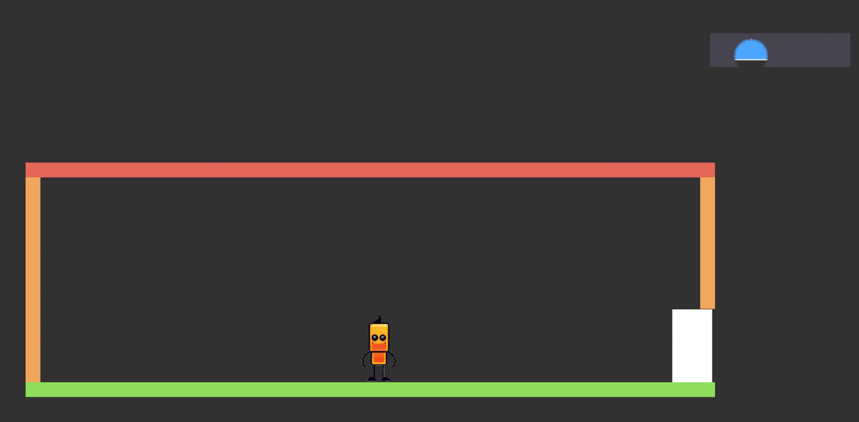

But the player is not showed in the map.We can add a icon for player.

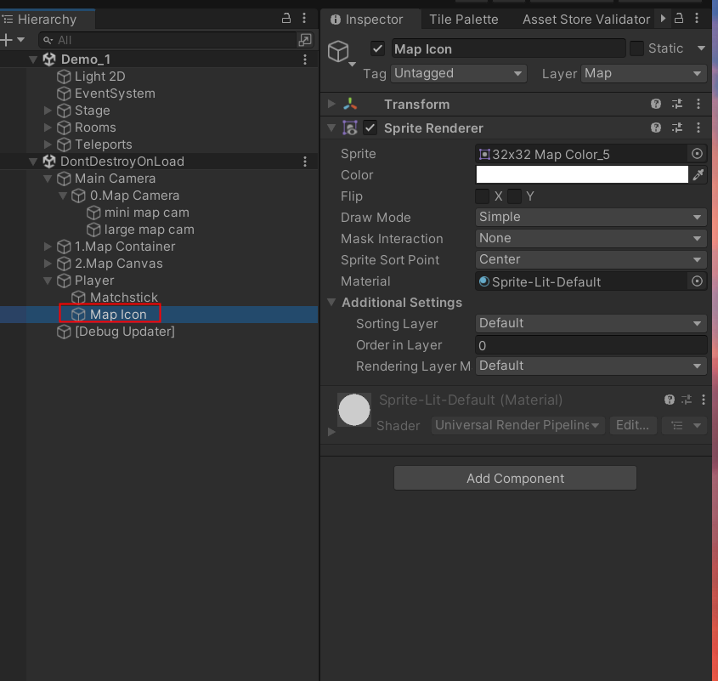

**Finally**

We’re done adding map functionality to Metroidvania.

Mini map:

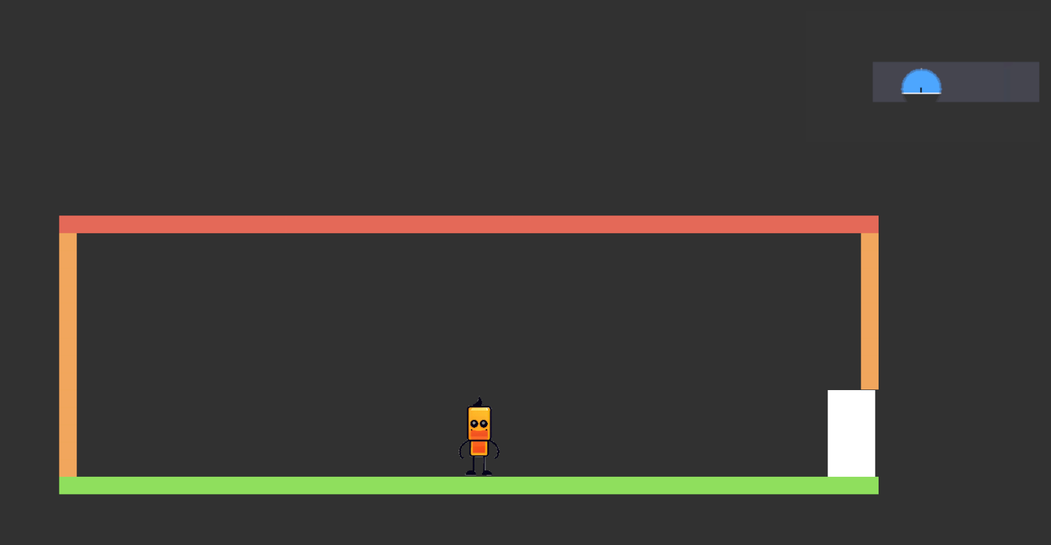

Large map:

